Qualification
BTEC Level 3 - Applied Science
Center Name | Center Registration No
ABC Horizon Academy | 91667
Student name | Assessor name
OZAN YILMAZ | Mr. Tareq ZAINALDIN
Unit Number/Name
Unit 28: Sustainable Energy
Assignment number and title | Submitted on
- Impact of use of fossil fuels  - Alternative energy sources  - Benefits and disadvantages of the use of renewable energy | 31/03/2026

Student Declaration

Student signature:  Date: 31/03/2026

Part A

Impact of use of fossil fuels

Fossil Fuels
fossil fuels
Natural energy sources known as fossil fuels are created from the decomposing remains of extinct plants and animals that existed millions of years ago. This biological material was eventually converted into fuels like coal, oil, and natural gas by the Earth's internal heat and pressure. These fuels are used to create energy for transportation, industry, and power. Because fossil fuels take millions of years to develop and are used by humans far more quickly than they can be replenished naturally, they are regarded as non-renewable resources. (U.S. Energy Information Administration (n.d.). Fossil fuels. Available at: https://www.eia.gov/tools/glossary/index.php?id=Fossil+fuel (Accessed: 28 March 2026).)
References
https://www.eia.gov/tools/glossary/index.php?id=Fossil+fuel&utm_
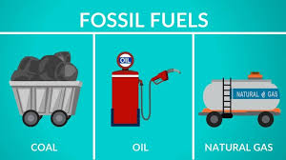

Figure 1Main types of fossil fuels: coal, oil, and natural gas.

Introduction to coal
A primary fossil fuel, coal is a solid, carbon-rich substance that is found in stratified sedimentary strata and is usually brown or black in color. Due to the compaction and hardening of modified plant remnants, such as peat, it has more than 50% carbon by weight (or 70% by volume). (U.S. Energy Information Administration (n.d.). Fossil fuels. Available at: https://www.eia.gov/tools/glossary/index.php?id=Fossil+fuel (Accessed: 28 March 2026).)
The initial plant material (coal type), the level of coalification (coal rank), and the impurities (coal grade) all influence the different forms of coal.The stages of coalification are lignite, subbituminous, bituminous, and anthracite.Combustion, which supplies heat to power plants, is the most important use of coal. Additionally, it can be transformed into liquid, gaseous, and solid products. However, using coal is linked to air pollution and carbon dioxide emissions, which are significant causes of global warming. (U.S. Energy Information Administration (n.d.). Coal explained. Available at: https://www.eia.gov/energyexplained/coal/ (Accessed: 28 March 2026).)

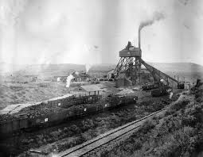
History of Coal
Coal has been used for thousands of years. Around 1000 BCE, evidence indicates that coal was utilized as a fuel in ancient China. Coal was later utilized by the Romans in Britain for both metallurgy and heating. During the Industrial Revolution in the 18th and 19th centuries, coal became crucial. Steam engines, factories, trains, and ships were all powered by coal during this time. This made it possible for enterprises to expand quickly and altered manufacturing and transportation. Coal remained a significant global energy source in the 20th century, particularly for the generation of electricity. However, many nations are currently attempting to cut back on coal use and switch to greener energy sources like solar, wind, and natural gas due to worries about pollution and climate change. . (U.S. Energy Information Administration (n.d.). Coal explained. Available at: https://www.eia.gov/energyexplained/coal/ (Accessed: 28 March 2026).)
References
https://www.eia.gov/energyexplained/coal/ https://education.nationalgeographic.org/resource/coal/ https://www.britannica.com/science/coal-fossil-fuel https://www.worldcoal.org/coal/what-coal
Introduction to Oil (Petroleum)
One of the most significant fossil fuels used in the modern world is oil, often known as petroleum.Fossil fuels are energy sources made from the remains of extinct plants and animals that were buried beneath sediment and rock layers millions of years ago. These biological remnants were eventually converted into hydrocarbons like coal, oil, and natural gas by heat and pressure.Microscopic marine animals like plankton and algae that once inhabited lakes and oceans millions of years ago are the primary source of petroleum. These species were buried by sediments when they perished and settled on the bottom of bodies of water. Deep underground, the organic matter underwent a gradual transformation into hydrocarbons under high pressure and temperature, resulting in the formation of natural gas and crude oil. . (U.S. Energy Information Administration (n.d.). Fossil fuels. Available at: https://www.eia.gov/tools/glossary/index.php?id=Fossil+fuel (Accessed: 28 March 2026).)
Globally, oil is an essential energy source. It is refined into a variety of goods, including chemicals, polymers, lubricants, jet fuel, gasoline, and diesel. Petroleum has been crucial to global transportation and industrial development because to its high energy content and adaptability. . (Encyclopaedia Britannica (n.d.). Petroleum. Available at: https://www.britannica.com/science/petroleum (Accessed: 28 March 2026).)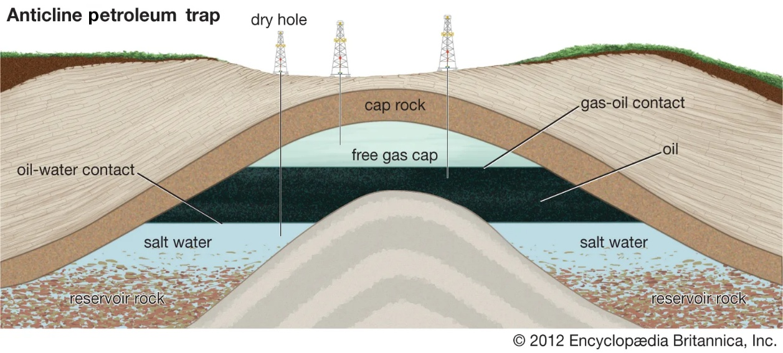
History of oil
Petroleum has been used for thousands of years.Oil was found spontaneously oozing from the earth and utilized for many purposes by ancient societies. .(Encyclopaedia Britannica (n.d.). Petroleum. Available at: https://www.britannica.com/science/petroleum (Accessed: 28 March 2026).)
Early Drilling and Development:
Using bamboo drilling instruments, one of the first oil wells ever discovered was drilled in China in 347 CE. To create salt and evaporate brine, the produced oil was burned. . (Encyclopaedia Britannica (n.d.). Petroleum. Available at: https://www.britannica.com/science/petroleum (Accessed: 28 March 2026).)
Beginning of the Modern Oil Industry:
When Edwin Drake drilled the first profitable commercial oil well in Titusville, Pennsylvania, USA, in 1859, the modern petroleum industry was born. This event signaled the start of big-scale oil production and proved that vast amounts of oil could be retrieved from subterranean sources.Following this discovery, oil production quickly increased globally. The global petroleum business grew quickly by the late 19th century when oil reserves were found throughout the United States, as well as in some parts of Europe and Asia. . (Encyclopaedia Britannica (n.d.). Petroleum. Available at: https://www.britannica.com/science/petroleum (Accessed: 28 March 2026).)

References
https://www.britannica.com/science/petroleum https://www.britannica.com/topic/How-Was-Petroleum-Discovered https://en.wikipedia.org/wiki/Petroleum https://en.wikipedia.org/wiki/Fossil_fuel https://guides.loc.gov/oil-and-gas-industry/history
Introduction to Natural Gas
Deep down, natural gas is a naturally occurring blend of hydrocarbon gasses and a fossil fuel.Methane (CH₄) makes up the majority of it, with smaller amounts of butane, ethane, and propane.Natural gas is extremely combustible, odorless, and colorless. It is extensively utilized as a fuel for automobiles and as a source of energy for cooking, heating, and electricity production. It also plays a significant role as a raw material in the manufacturing of plastics, chemicals, and fertilizers. Natural gas is frequently regarded as one of the cleaner fossil fuels used for energy today because it burns more cleanly than coal or oil. . (U.S. Energy Information Administration (n.d.). Fossil fuels. Available at: https://www.eia.gov/tools/glossary/index.php?id=Fossil+fuel (Accessed: 28 March 2026).)
History of Natural Gas
Natural gas has a long history that spans thousands of years. There is evidence that natural gas leaks were originally found in parts of the Middle East, particularly in modern-day Iran and Azerbaijan, between 6000 and 2000 BCE. In these locations, lightning occasionally ignited gas that was escaping from the earth, resulting in what the locals referred to as "eternal fires." In ancient Persian cultures, these fires were connected to sacred rituals. . (Encyclopaedia Britannica (n.d.). Natural gas. Available at: https://www.britannica.com/science/natural-gas (Accessed: 28 March 2026).)
Around 900 BCE, one of the first reported uses of natural gas took place in ancient China. The Chinese learnt how to drill wells and transfer gas through bamboo tubes. They primarily used natural gas to boil saltwater and extract salt. By 211 BCE, the Chinese had bored wells to depths of approximately 150 meters to access natural gas resources.. (Encyclopaedia Britannica (n.d.). Petroleum. Available at: https://www.britannica.com/science/petroleum (Accessed: 28 March 2026).)
It wasn't until it was found in England in 1659 that natural gas gained widespread recognition throughout Europe. But it wasn't until the late 18th century that gas made from coal was widely used to light homes and streets. William Hart drilled the nation's first successful commercial natural gas well in Fredonia, New York, in 1821.This well's gas was piped and used for cooking and lighting. (U.S. Energy Information Administration (n.d.). Coal explained. Available at: https://www.eia.gov/energyexplained/coal/ (Accessed: 28 March 2026).)
Because it was challenging to transport natural gas across vast distances, its use remained restricted during the 19th century. Natural gas became a significant worldwide energy source in the 20th century with the construction of pipelines and advancements in extraction techniques. These days, it is essential to the world's industrial processes, domestic energy supply, and electricity production(Encyclopaedia Britannica (n.d.). Natural gas. Available at: https://www.britannica.com/science/natural-gas (Accessed: 28 March 2026).)
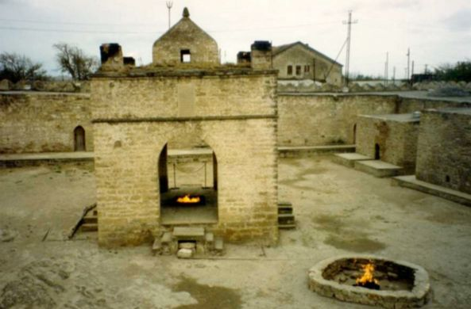
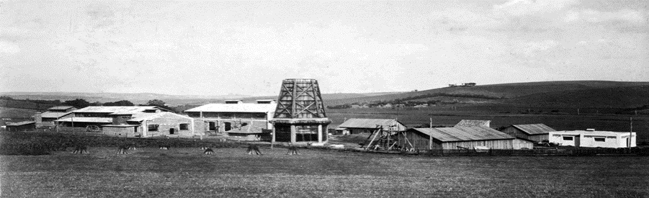
Hand-dug oil wells at Bibi-Eibat, Azerbaijan, mid-1800s?
From : San Joaquin Geological Society.
References
https://www.britannica.com/science/natural-gas https://www.apga.org/apgamainsite/aboutus/facts/history-of-natural-gas https://group.met.com/en/media/energy-insight/when-was-natural-gas-first-used

Where coal comes from
The remains of extinct plants that existed millions of years ago give rise to coal, a fossil fuel. Plant matter was buried beneath layers of rock and soil over extended periods of time. This substance was converted into coal seams under the Earth's surface by heat and pressure. These coal resources might be found deep underground or near the surface. . (U.S. Energy Information Administration (n.d.). Fossil fuels. Available at: https://www.eia.gov/tools/glossary/index.php?id=Fossil+fuel (Accessed: 28 March 2026).)
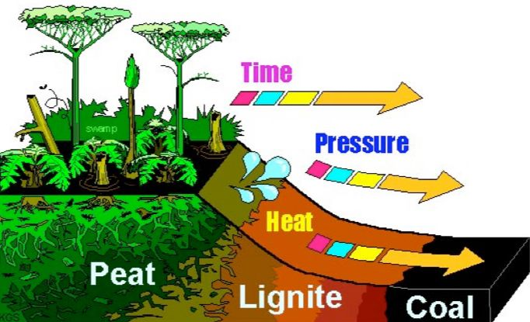

How Formed?
Coal mining is the process of extracting coal from the earth. Coal is extracted using two primary methods:
1. Surface mining
When coal reserves are near the Earth's surface, surface mining is employed. This technique exposes the coal seam by using big machinery to remove layers of rock, vegetation, and soil (referred to as overburden). The coal is broken up and delivered to processing plants after it has been exposed. In general, surface mining is less expensive and enables the extraction of more coal in less time(U.S. Energy Information Administration (n.d.). Coal explained. Available at: https://www.eia.gov/energyexplained/coal/ (Accessed: 28 March 2026).)

Strip Mining
In order to access coal seams that are close to the surface, strip mining entails removing lengthy strips of rock and soil (overburden). It is among the most used techniques for surface mining. . (U.S. Energy Information Administration (n.d.). Coal explained. Available at: https://www.eia.gov/energyexplained/coal/ (Accessed: 28 March 2026).)

Open-Pit Mining
Large open holes or pits are used in open-pit mining to extract coal. Coal is removed and transported to processing facilities using large gear. . (U.S. Energy Information Administration (n.d.). Coal explained. Available at: https://www.eia.gov/energyexplained/coal/ (Accessed: 28 March 2026).)

Mountaintop Removal Mining
In order to reveal coal seams beneath a mountain, mountaintop removal mining eliminates the top of the mountain. The rock layers above the coal are removed using explosives and big machinery. (U.S. Energy Information Administration (n.d.). Coal explained. Available at: https://www.eia.gov/energyexplained/coal/ (Accessed: 28 March 2026).)

Highwall Mining
When surface mining approaches its limit, highwall mining is employed. To extract more coal, machines drill horizontally into the mine's exposed wall. . (U.S. Energy Information Administration (n.d.). Coal explained. Available at: https://www.eia.gov/energyexplained/coal/ (Accessed: 28 March 2026).)

Auger Mining
Auger mining extracts coal that is unreachable by other mining techniques by boring into the coal seam from the highwall using a big spinning drill(U.S. Energy Information Administration (n.d.). Coal explained. Available at: https://www.eia.gov/energyexplained/coal/ (Accessed: 28 March 2026).)

2. Underground mining
When coal resources are located far below the surface, underground mining is utilized. To get to the coal seam, miners excavate tunnels or shafts.These tunnels are used by laborers and equipment to cut and move coal to the surface.Because miners operate deep down, subterranean mining is more complicated and necessitates safety precautions and ventilation systems. (U.S. Energy Information Administration (n.d.). Coal explained. Available at: https://www.eia.gov/energyexplained/coal/ (Accessed: 28 March 2026).)

Room-and-Pillar Mining
Using this technique, miners extract coal from vast chambers, leaving coal pillars to support the mine's roof. . (U.S. Energy Information Administration (n.d.). Coal explained. Available at: https://www.eia.gov/energyexplained/coal/ (Accessed: 28 March 2026).)

Longwall Mining
In longwall mining, the roof is held in place by hydraulic supports while a massive cutting machine travels along the coal seam. It is among the most effective methods of underground mining. . (U.S. Energy Information Administration (n.d.). Coal explained. Available at: https://www.eia.gov/energyexplained/coal/ (Accessed: 28 March 2026).)

Shaft Mining
Digging vertical shafts from the surface to deep coal seams is known as shaft mining. (U.S. Energy Information Administration (n.d.). Coal explained. Available at: https://www.eia.gov/energyexplained/coal/ (Accessed: 28 March 2026).)

Drift Mining
When coal seams are visible on the side of a hill or mountain, drift mining takes place. Directly into the coal seam, miners excavate horizontal tunnels. (U.S. Energy Information Administration (n.d.). Coal explained. Available at: https://www.eia.gov/energyexplained/coal/ (Accessed: 28 March 2026).)
Slope Mining
An inclined tunnel that tracks the coal seam's subsurface slope is used in slope mining.
3. Other Coal Extraction Technologies
Underground Coal Gasification
While coal is still underground, underground coal gasification transforms it into gas. When air or oxygen is pumped into the coal seam, fuel-grade gas is produced. (U.S. Energy Information Administration (n.d.). Coal explained. Available at: https://www.eia.gov/energyexplained/coal/ (Accessed: 28 March 2026).

Drilling and Fracturing
Drilling methods are employed in certain fossil fuel businesses to access subterranean resources.Drilling may be utilized in associated energy extraction procedures like coalbed methane recovery or coal deposit discovery, even if coal is primarily mined. (U.S. Energy Information Administration (n.d.). Fossil fuels. Available at: https://www.eia.gov/tools/glossary/index.php?id=Fossil+fuel (Accessed: 28 March 2026).)
References
https://www.eia.gov/energyexplained/coal/mining-and-transportation.php https://education.nationalgeographic.org/resource/coal/ https://www.britannica.com/technology/coal-mining https://www.eia.gov/energyexplained/coal/mining-and-transportation.php https://education.nationalgeographic.org/resource/coal/ https://www.britannica.com/technology/coal-mining https://www.worldcoal.org/coal/what-coal/coal-mining

How Oil is extracted
Petroleum, or oil, is a fossil fuel that can be discovered in rock formations far below the surface. Depending on the location and depth of the oil reservoir, various extraction techniques are employed to acquire crude oil. (U.S. Energy Information Administration (n.d.). Fossil fuels. Available at: https://www.eia.gov/tools/glossary/index.php?id=Fossil+fuel (Accessed: 28 March 2026).)
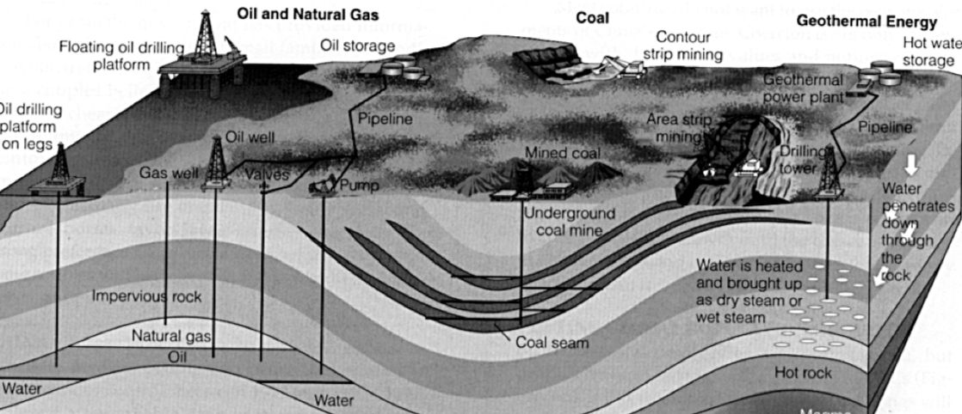
1. Onshore Drilling
Oil extraction from land-based reservoirs is referred to as "onshore drilling." Deep wells are drilled by a drilling rig into subterranean rock formations that contain trapped oil. The oil travels through the well to the surface and is collected for processing once the reservoir is reached. . (Encyclopaedia Britannica (n.d.). Petroleum. Available at: https://www.britannica.com/science/petroleum (Accessed: 28 March 2026).)

2. Offshore Drilling
Oil beneath the ocean floor is extracted by offshore drilling. To drill wells into undersea oil deposits, special drilling platforms are constructed underwater. After that, the oil is sent to refineries on land via pipelines or ships. (Encyclopaedia Britannica (n.d.). Petroleum. Available at: https://www.britannica.com/science/petroleum (Accessed: 28 March 2026).)

3. Fracking (Hydraulic Fracturing)
One method for getting oil out of tight rock formations like shale is hydraulic fracturing. This technique involves injecting a high-pressure mixture of water, sand, and chemicals into the rock. Oil can enter the well and be pumped to the surface because the pressure causes tiny cracks in the rock.
References
https://www.eia.gov/energyexplained/oil-and-petroleum-products/ https://www.britannica.com/science/petroleum https://www.iea.org/energy-system/fossil-fuels/oil
How Natural Gas Extracted
Fossil fuels like natural gas can be discovered deep within rock formations, frequently with coal or oil reserves. Depending on the location and geological characteristics of the gas reservoir, many techniques are employed to extract natural gas. . (U.S. Energy Information Administration (n.d.). Fossil fuels. Available at: https://www.eia.gov/tools/glossary/index.php?id=Fossil+fuel (Accessed: 28 March 2026).)
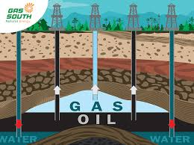

1. Surface Mining
When coal deposits are linked to natural gas, surface mining may be utilized. In this instance, surface mining techniques are used to extract coal, and throughout the mining operation, coalbed methane—a gas trapped in the coal layers—is collected. (U.S. Energy Information Administration (n.d.). Coal explained. Available at: https://www.eia.gov/energyexplained/coal/ (Accessed: 28 March 2026).)

2. Underground Mining
Underground mining is employed when natural gas-containing coal reserves are found deep underground. Methane gas contained in the coal strata is released during coal seam mining and collected using ventilation or specialized gas collection devices. (U.S. Energy Information Administration (n.d.). Coal explained. Available at: https://www.eia.gov/energyexplained/coal/ (Accessed: 28 March 2026).)

3. Onshore Drilling
The most popular technique for obtaining natural gas from land-based reservoirs is onshore drilling.Deep wells are drilled by a drilling rig into subterranean rock formations that contain trapped gas. Natural gas travels from the well to the surface and is collected via pipes after it reaches the gas reservoir. (Encyclopaedia Britannica (n.d.). Natural gas. Available at: https://www.britannica.com/science/natural-gas (Accessed: 28 March 2026).)

4. Offshore Drilling
Natural gas beneath the seafloor is extracted through offshore drilling. To drill wells into underwater gas reservoirs, large drilling platforms are placed in seas or oceans. After that, pipelines or specialized tankers are used to move the gas to land. (Encyclopaedia Britannica (n.d.). Natural gas. Available at: https://www.britannica.com/science/natural-gas (Accessed: 28 March 2026).

5. Fracking (Hydraulic Fracturing)
Natural gas is extracted from tight rock formations like shale via a process called hydraulic fracturing, or fracking. A high-pressure mixture of water, sand, and trace amounts of chemicals is injected into the rock during this process. The rock layers may fracture, allowing natural gas to enter the hole and be pushed to the surface. (Encyclopaedia Britannica (n.d.). Natural gas. Available at: https://www.britannica.com/science/natural-gas (Accessed: 28 March 2026).
References
https://www.eia.gov/energyexplained/natural-gas/ https://www.iea.org/energy-system/fossil-fuels/natural-gas https://www.britannica.com/science/natural-gas

Uses of Coal
One of the most significant fossil fuels for industrial processes and energy production is coal. The remains of plants that formerly existed millions of years ago gave rise to this flammable rock. Coal has several uses since it burns with a lot of heat due to its high carbon content. (U.S. Energy Information Administration (n.d.). Fossil fuels. Available at: https://www.eia.gov/tools/glossary/index.php?id=Fossil+fuel (Accessed: 28 March 2026).
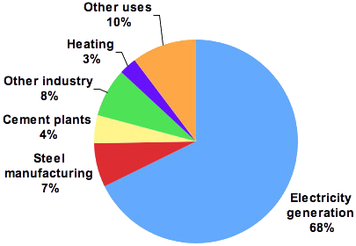

1. Electricity Generation
Coal is mostly used to produce power. Coal is burned in coal-fired power plants to generate heat, which turns water into steam. Steam generates power by turning turbines that are connected to generators. Because coal is plentiful and reasonably priced, many nations have relied on it to generate power. (U.S. Energy Information Administration (n.d.). Coal explained. Available at: https://www.eia.gov/energyexplained/coal/ (Accessed: 28 March 2026).

2. Steel Production
In the steel business, coal is essential. Iron is produced from iron ore in blast furnaces using coke, a refined form of coal. After that, the iron is turned into steel, which is utilized in manufacturing, transportation, and building. (U.S. Energy Information Administration (n.d.). Coal explained. Available at: https://www.eia.gov/energyexplained/coal/ (Accessed: 28 March 2026).

3. Cement Manufacturing
The cement industry uses coal as fuel. Cement production requires high temperatures, and coal is burned in cement kilns to supply the necessary heat. (U.S. Energy Information Administration (n.d.). Coal explained. Available at: https://www.eia.gov/energyexplained/coal/ (Accessed: 28 March 2026).

4. Industrial Heating
Coal is a common source of heat 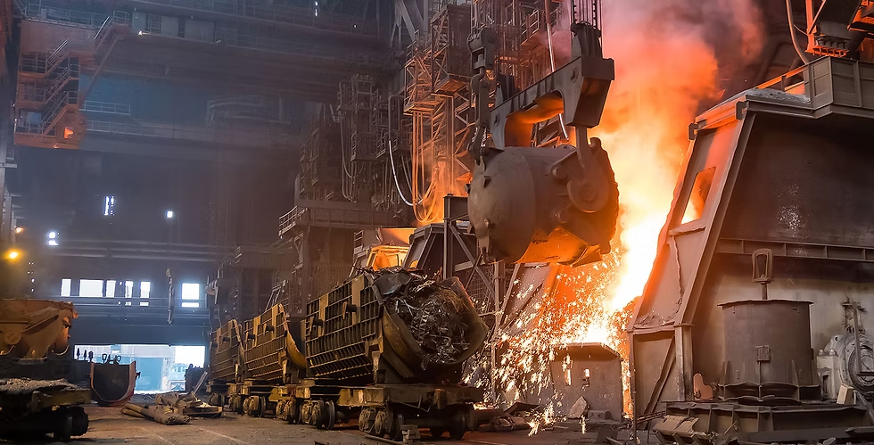for manufacturing processes. Because it can produce high temperatures, it is employed in sectors including chemical production, brick manufacture, and paper manufacturing. (U.S. Energy Information Administration (n.d.). Coal explained. Available at: https://www.eia.gov/energyexplained/coal/ (Accessed: 28 March 2026).

5. Production of Chemicals
Chemicals like coal tar, synthetic fuels, fertilizers, and some polymers can also be made from coal.Numerous industrial and manufacturing operations depend on these compounds. . (U.S. Energy Information Administration (n.d.). Coal explained. Available at: https://www.eia.gov/energyexplained/coal/ (Accessed: 28 March 2026).
References
https://www.eia.gov/energyexplained/oil-and-petroleum-products/
https://www.britannica.com/science/petroleum
https://www.iea.org/energy-system/fossil-fuels/oil

Uses of Oil
One of the most significant fossil fuels in the world is oil (petroleum). It is extensively utilized as a raw material for numerous industrial items as well as a source of energy. (U.S. Energy Information Administration (n.d.). Fossil fuels. Available at: https://www.eia.gov/tools/glossary/index.php?id=Fossil+fuel (Accessed: 28 March 2026).

1. Power Generation
Power plants burn oil to generate electricity.Steam is created from the heat produced by burning oil, and this steam powers turbines that produce electricity. (Encyclopaedia Britannica (n.d.). Petroleum. Available at: https://www.britannica.com/science/petroleum (Accessed: 28 March 2026).

2. Transportation Fuel
In order to power automobiles, trucks, aeroplanes, and ships, oil is refined into fuels like petrol, diesel, and jet fuel. As a result, one of the primary energy sources for international transportation is oil. (Encyclopaedia Britannica (n.d.). Petroleum. Available at: https://www.britannica.com/science/petroleum (Accessed: 28 March 2026).

3. Heating and Cooking
Oil products like kerosene and heating oil are utilized in many areas for cooking and house heating. (Encyclopaedia Britannica (n.d.). Petroleum. Available at: https://www.britannica.com/science/petroleum (Accessed: 28 March 2026).

4. Industrial and Manufacturing Uses(28 March 2026).)
Oil is an important raw material used to manufacture many products such as:
plastics
synthetic rubber
lubricants
detergents
paints and solvents

5. Petrochemical Products
Many petrochemical products, such as fertilizers, medications, cosmetics, and synthetic fibers used in apparel, are made from oil. (Encyclopaedia Britannica (n.d.). Petroleum. Available at: https://www.britannica.com/science/petroleum (Accessed: 28 March 2026).
References
https://www.eia.gov/energyexplained/oil-and-petroleum-products https://www.iea.org/energy-system/fossil-fuels/oil https://www.britannica.com/science/petroleum

Uses of Natural Gas
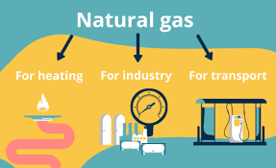
One of the most popular fossil fuels in the world is natural gas. Because it burns cleaner than other fossil fuels like coal and oil, it is prized. Methane, a hydrocarbon that releases energy when burned, makes up the majority of natural gas. It is utilized in a variety of fields, such as industrial, (U.S. Energy Information Administration (n.d.). Fossil fuels. Available at: https://www.eia.gov/tools/glossary/index.php?id=Fossil+fuel (Accessed: 28 March 2026).

1. Electricity Generation transportation, heating, and the production of power. First. Electricity generation is one of the primary uses of natural gas. Natural gas is used in power plants to generate steam, which powers turbines that are attached to generators. Because natural gas power plants are more efficient and emit fewer carbon emissions than coal-fired ones, several nations employ them. (U.S. Energy Information Administration (n.d.). Coal explained. Available at: https://www.eia.gov/energyexplained/coal/ (Accessed: 28 March 2026).

2. Heating and Cooking
In houses and buildings, natural gas is frequently utilized for cooking, heating, and hot water. Gas burners are frequently used in kitchens because they enable rapid and controlled heating, while gas furnaces and boilers supply heat throughout the winter. Encyclopaedia Britannica (n.d.). Petroleum. Available at: https://www.britannica.com/science/petroleum (Accessed: 28 March 2026).

3. Industrial Use
Natural gas is used by industries as a raw material and a fuel. Steel, glass, paper, and food goods are among the production processes that use it. The high temperatures needed for numerous industrial processes are likewise supplied by natural gas. (Encyclopaedia Britannica (n.d.). Natural gas. Available at: https://www.britannica.com/science/natural-gas (Accessed: 28 March 2026).

4. Production of Chemicals and Fertilizers
In the chemical industry, natural gas is a crucial raw ingredient. Ammonia and hydrogen, two essential components of fertilizers, are produced using it. Natural gas-based fertilizers contribute to global agricultural productivity growth. (Encyclopaedia Britannica (n.d.). Natural gas. Available at: https://www.britannica.com/science/natural-gas (Accessed: 28 March 2026).

5. Transportation Fuel
Compressed natural gas (CNG) and liquefied natural gas (LNG) are two other forms of natural gas that can be utilized as a fuel for vehicles.Natural gas is used in some cars, trucks, and buses because it emits fewer emissions than gasoline or diesel. (Encyclopaedia Britannica (n.d.). Natural gas. Available at: https://www.britannica.com/science/natural-gas (Accessed: 28 March 2026).

6. Heating in Industry and Buildings
Large buildings including offices, schools, and hospitals are frequently heated by natural gas.Additionally, it is utilized for material processing and heating in industrial boilers and furnaces. . (Encyclopaedia Britannica (n.d.). Petroleum. Available at: https://www.britannica.com/science/petroleum (Accessed: 28 March 2026).
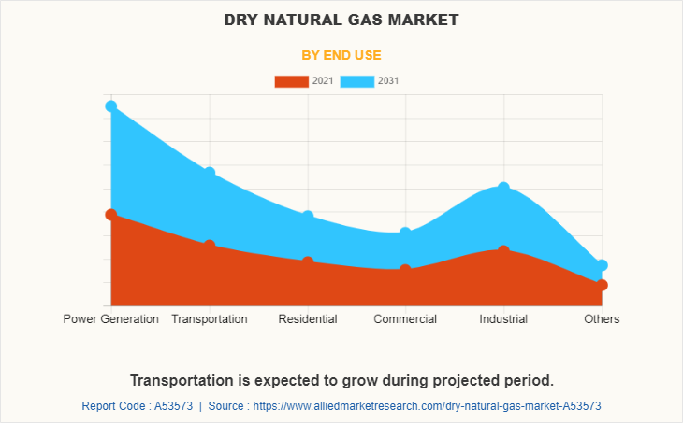
References
https://www.eia.gov/energyexplained/natural-gas/use-of-natural-gas.php https://www.britannica.com/science/natural-gas https://www.iea.org/energy-system/fossil-fuels/natural-gas https://education.nationalgeographic.org/resource/natural-gas/
Explain How the Use of Coal (Fossil Fuels) Affects Human Health and the Environment
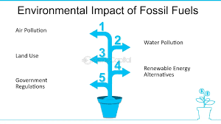

The environment and human health are significantly impacted by the usage of coal as a fossil fuel. Large volumes of carbon dioxide and other dangerous pollutants are released into the atmosphere when coal is burned in power plants to produce energy. Sulfur dioxide, nitrogen oxides, and particulate matter are some of the pollutants that cause air pollution and climate change. (U.S. Energy Information Administration (n.d.). Fossil fuels. Available at: https://www.eia.gov/tools/glossary/index.php?id=Fossil+fuel (Accessed: 28 March 2026).

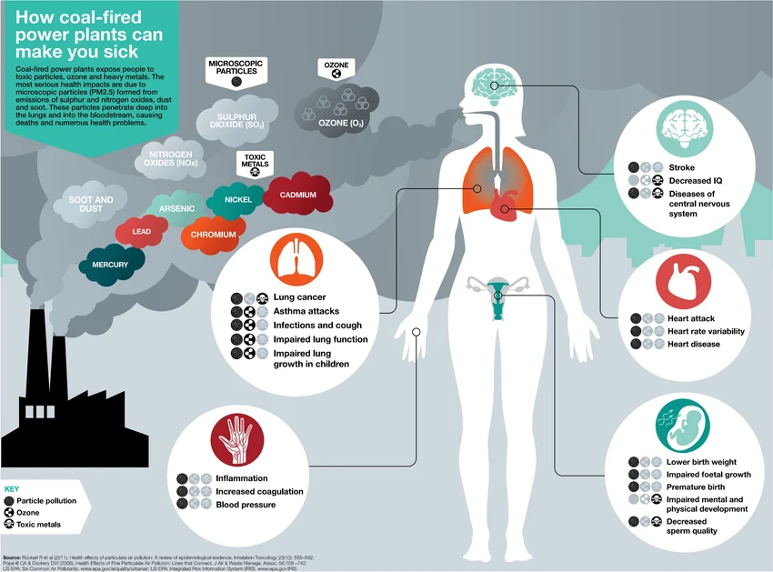
Human health can be adversely affected by coal combustion-related air pollution. The risk of respiratory conditions including bronchitis, asthma, and other lung issues might be raised by exposure to contaminated air. The risk of heart disease may also rise with prolonged exposure.

The environment is also harmed by the mining and burning of coal. Mining operations have the potential to contaminate water supplies with hazardous materials, degrade natural landscapes, and harm ecosystems. Furthermore, burning coal releases greenhouse gasses that fuel global warming. . (U.S. Energy Information Administration (n.d.). Coal explained. Available at: https://www.eia.gov/energyexplained/coal/ (Accessed: 28 March 2026).

Describe How the Use of Coal Impacts Human Health and the Environment

The environment and human health are impacted by coal use in a number of ways. Air pollution from burning coal is one significant effect.Particularly for those who live close to coal-fired power plants or mining sites, this pollution lowers air quality and can cause major health issues. (U.S. Energy Information Administration (n.d.). Coal explained. Available at: https://www.eia.gov/energyexplained/coal/ (Accessed: 28 March 2026).
The harm coal mining causes to the environment is another effect. Both surface and underground mining have the potential to disrupt wildlife habitats, alter soil, and remove vegetation.Additionally, groundwater and rivers may become contaminated by mining waste. . (U.S. Energy Information Administration (n.d.). Coal explained. Available at: https://www.eia.gov/energyexplained/coal/ (Accessed: 28 March 2026).)
Because burning coal releases a lot of carbon dioxide, it also significantly contributes to climate change. Rising temperatures, harsh weather, and detrimental effects on ecosystems and human societies are all possible outcomes of climate change. . (U.S. Energy Information Administration (n.d.). Coal explained. Available at: https://www.eia.gov/energyexplained/coal/ (Accessed: 28 March 2026).
References
https://www.eia.gov/energyexplained/coal/ https://www.britannica.com/science/coal https://www.iea.org/energy-system/fossil-fuels/coal

Explain How the Use of Oil (Fossil Fuels) Affects Human Health and the Environment
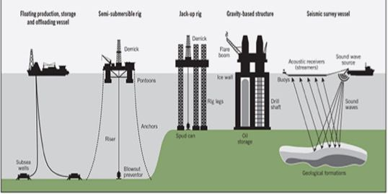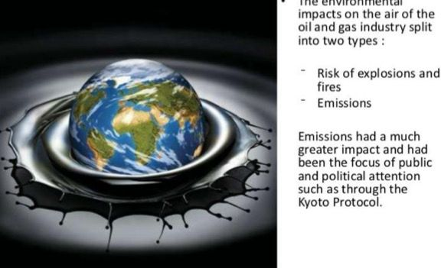
The environment and human health may be impacted by the usage of oil as a fossil fuel.Pollutants are released into the air when oil products like gasoline and diesel are burned in factories, power plants, and automobiles.Particulate matter, carbon dioxide, and nitrogen oxides are some of these pollutants that cause air pollution and climate change. . (U.S. Energy Information Administration (n.d.). Fossil fuels. Available at: https://www.eia.gov/tools/glossary/index.php?id=Fossil+fuel (Accessed: 28 March 2026).
By raising the risk of respiratory conditions like bronchitis and asthma, air pollution from burning oil can be detrimental to human health.
The heart and lungs may also be impacted by prolonged exposure to contaminated air.
Transportation and oil production can potentially have negative environmental effects.Soil, rivers, and oceans can become contaminated by oil spills from pipelines or tankers. This pollution can damage ecosystems and harm wildlife such as fish, birds, and marine mammals. (Encyclopaedia Britannica (n.d.). Petroleum. Available at: https://www.britannica.com/science/petroleum (Accessed: 28 March 2026).

Describe How the Use of Oil Impacts Human Health and the Environment

The environment and human health are impacted by oil use in a number of ways. Burning oil releases greenhouse gasses, which is one of the main effects. Extreme weather, rising sea levels, and ecological changes can result from these gases' contribution to global warming and climate change. (Encyclopaedia Britannica (n.d.). Petroleum. Available at: https://www.britannica.com/science/petroleum (Accessed: 28 March 2026).
Exposure to hazardous materials during the extraction and refining of oil has an additional effect. Hazardous chemical exposure may have an impact on the respiratory system and general health of workers and the surrounding community. (Encyclopaedia Britannica (n.d.). Petroleum. Available at: https://www.britannica.com/science/petroleum (Accessed: 28 March 2026).
Water contamination, drilling-related land disturbance, and oil spills can all cause\ environmental harm. These actions could damage natural ecosystems, diminish biodiversity, and eliminate habitats. . (Encyclopaedia Britannica (n.d.). Petroleum. Available at: https://www.britannica.com/science/petroleum (Accessed: 28 March 2026).
References
https://www.eia.gov/energyexplained/oil-and-petroleum-products/ https://www.britannica.com/science/petroleum https://www.iea.org/energy-system/fossil-fuels/oil

Explain How the Use of Natural Gas (Fossil Fuels) Affects Human Health and the Environment

The environment and human health may be impacted by the usage of natural gas as a fossil fuel. Gases like carbon dioxide and nitrogen oxides are released into the environment when natural gas is burnt for cooking, heating, and electricity production. Both air pollution and climate change are caused by these emissions. (U.S. Energy Information Administration (n.d.). Fossil fuels. Available at: https://www.eia.gov/tools/glossary/index.php?id=Fossil+fuel (Accessed: 28 March 2026).

Human health, particularly the respiratory system, can be impacted by air pollution from burning natural gas. Pollution exposure may raise the risk of lung inflammation, asthma, and other respiratory issues. Methane, a potent greenhouse gas that contributes to global warming, can occasionally be released by natural gas leaks during extraction or transportation. (Encyclopaedia Britannica (n.d.). Natural gas. Available at: https://www.britannica.com/science/natural-gas (Accessed: 28 March 2026).

Drilling and hydraulic fracturing are two methods of extracting natural gas that may have an impact on the environment. These processes can lead to water contamination, land disturbance, and habitat disruption. (Encyclopaedia Britannica (n.d.). Natural gas. Available at: https://www.britannica.com/science/natural-gas (Accessed: 28 March 2026).

Describe How the Use of Natural Gas Impacts Human Health and the Environment

The use of natural gas has many effects on both the environment and human health. Natural gas releases greenhouse emissions that contribute to climate change even though it burns cleaner than coal and oil. Elevated temperatures, harsh weather, and altered ecosystems are all consequences of climate change. (U.S. Energy Information Administration (n.d.). Coal explained. Available at: https://www.eia.gov/energyexplained/coal/ (Accessed: 28 March 2026).)

Air pollutants including nitrogen oxides and volatile organic compounds may also be released during natural gas operations. In neighboring areas, these pollutants can worsen the quality of the air and raise the risk of respiratory ailments. (Encyclopaedia Britannica (n.d.). Natural gas. Available at: https://www.britannica.com/science/natural-gas (Accessed: 28 March 2026).)
Methane leakage, water use, and possible groundwater contamination are more ways that the extraction and transportation of natural gas can impact the environment. Natural resources, wildlife, and ecosystems may be harmed by these effects. (Encyclopaedia Britannica (n.d.). Natural gas. Available at: https://www.britannica.com/science/natural-gas (Accessed: 28 March 2026).)
References
https://www.eia.gov/energyexplained/natural-gas/ https://www.iea.org/energy-system/fossil-fuels/natural-gas https://www.britannica.com/science/natural-gas
Effect on Climate – Coal
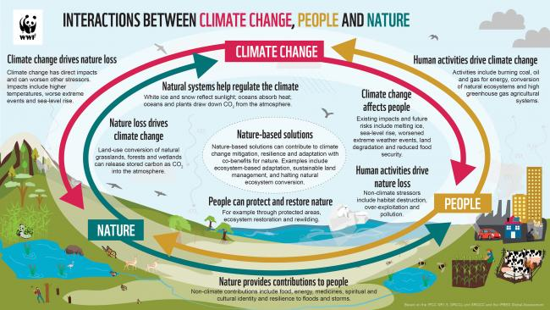
Among fossil fuels, coal has one of the biggest effects on the climate. Carbon dioxide and other greenhouse gases are released into the environment in extremely large quantities when coal is burned. These emissions have a significant impact on climate change and global warming.Due to decreased rainfall and increased evaporation, severe droughts are becoming more likely in many areas as the climate warms.Additionally, more frequent and hazardous heatwaves may result from rising global temperatures. Furthermore, in many regions of the world, climate change can exacerbate weather systems, resulting in more powerful storms, intense rainfall, and flooding. (U.S. Energy Information Administration (n.d.). Fossil fuels. Available at: https://www.eia.gov/tools/glossary/index.php?id=Fossil+fuel (Accessed: 28 March 2026).)
References
https://www.iea.org/energy-system/fossil-fuels/coal https://www.britannica.com/science/coal
Effect on Climate – Oil

Because burning oil releases a lot of greenhouse gases, particularly carbon dioxide (CO₂), it has a big impact on the climate. These gases contribute to global warming by trapping heat in the atmosphere. Climate patterns shift as global temperatures rise.
Droughts may become more likely as a result, particularly in arid areas where rainfall is less regular. Heatwaves, which have an impact on human health, agriculture, and water supplies, can also become more frequent and intense due to rising temperatures. Furthermore, heavier and more powerful storms like hurricanes and typhoons might result from warmer oceans. (International Energy Agency (n.d.). Energy system. Available at: https://www.iea.org/energy-system/ (Accessed: 28 March 2026).)

References
https://www.iea.org/energy-system/fossil-fuels/oil https://www.eia.gov/energyexplained/oil-and-petroleum-products/
Effect on Climate – Natural Gas
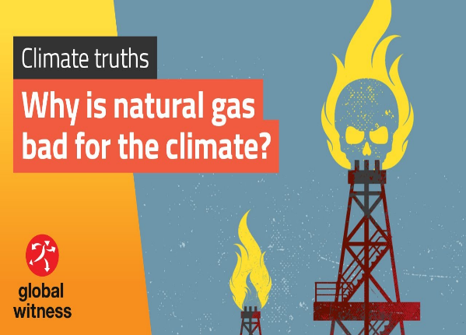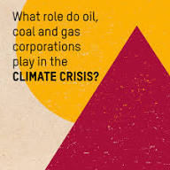
Natural gas also contributes to climate change when it is used as an energy source. Burning natural gas releases carbon dioxide, and leaks during production and transportation can release methane, a very powerful greenhouse gas. These emissions increase the greenhouse effect and raise global temperatures. (Encyclopaedia Britannica (n.d.). Natural gas. Available at: https://www.britannica.com/science/natural-gas (Accessed: 28 March 2026).)
Climate change caused by these emissions can lead to longer periods of drought, which affect water resources and agriculture. Higher temperatures may also increase the number of heatwaves around the world. In addition, warmer atmospheric and ocean conditions can cause more intense storms and extreme weather events. (International Energy Agency (n.d.). Energy system. Available at: https://www.iea.org/energy-system/ (Accessed: 28 March 2026).
References
International Energy Agency U.S. Energy Information Administration

PART B

Sustainable Energy – Alternative Energy Sources

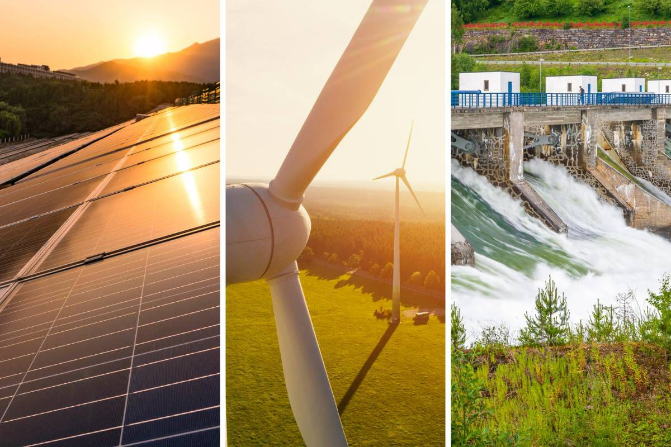

Introduction
Energy production is vital for our lives. However, conventional fuels, predominantly coal, oil and natural gases, have a high environmental cost and are generally unsustainable. Instead, there is a move towards renewable technologies, such as solar, wind, hydroelectric and biomass, in order to decrease carbon output and improve sustainability (International Energy Agency, 2023). This report will analyze a number of factors influencing the economic and operational efficiency of renewable energy and attempt comparisons with fossil fuels and nuclear power.

Evaluation of Factors Affecting Efficiency
There are a number of factors which may affect the efficiency of energy generation. Cost of construction is an issue. A renewable power station (solar farms, hydroelectric dams etc.) require a significant capital investment in infrastructure, equipment and installation (U.S. Energy Information Administration, 2023). However, operation is fairly cheap because there are no fuel costs. Maintenance and operational costs are the second constraint. A wind farm, hydroelectric or biomass power plant require regular monitoring and maintenance (International Energy Agency, 2023). Solar panels require little maintenance.

Levelised Cost of Electricity (LCOE)
The levelised cost of energy (LCOE) is an economic assessment used to compare the cost of various energy systems. It is defined as: [the] total cost of building and operating a power plant over its lifetime divided by its total power output (International Energy Agency, 2023).
The LCOE includes :
construction and installation
operation and maintenance
fuel, decommissioning and other costs.
The LCOE for renewable (e.g. solar, wind) generation technologies is now lower than the cost for fossil fuels, despite high up front construction costs for renewable generation, due to lower ongoing costs, particularly fuel costs. Improvements in manufacturing and technologies have led to a lower LCOE for wind and solar power in recent years (U.S. Energy Information Administration, 2023).

Technological Advances Improving Efficiency
The advances in technology have meant that renewable energy sources have become more cost effective and efficient. For instance, new wind turbines have more sophisticated blade design that allow for more of the kinetic energy of the wind to be captured and converted into electricity (International Energy Agency, 2023).
There have been developments in PV technology and the manufacturing processes involved that makes the generation of energy more effective (International Energy Agency, 2023).
Technologies such as lithium ion batteries mean that electricity generated from variable renewable energy sources such as solar and wind power can be stored and used when there is high demand ( Energy Saving Trust, 2023). Overall technological developments have meant that less energy is wasted and renewable power is less variable.

Renewable Energy Technologies
The technologies of solar, wind, hydropower, and biomass stand to deliver a cleaner alternative energy source. Solar uses photovoltaic cells, or solar panels that directly convert sunlight into electrical energy. Wind turbines turn moving wind into electrical energy. Hydropower turbines use flowing water to generate electricity. Biomass electricity is converted from organic matter such as croppings and wood or other waste material (National Geographic, 2022).

Solar Energy

Figure1: Solar photovoltaic panels converting sunlight into electrical energy using semiconductor photovoltaic cells.
Solar power is generated using solar photovoltaic cells, which contain semiconductor cells made of silicon. Light energy causes the electrons to move within the cell and thus generate electricity. Solar energy is a renewable and sustainable form, producing no direct carbon emissions. (Energy Saving Trust, 2023).
Evaluation: Clean, environmentally friendly, but efficiency can be affected by weather and sunlight levels.

Wind Energy

Figure 2: Wind turbines generating electricity by converting the kinetic energy of moving air into mechanical energy and then electrical energy.
Fundamentally, wind turbines generate power by capturing the kinetic energy of the wind, which rotates the blades of the turbine and potentially generate electricity through generators (International Energy Agency, 2023). Most wind farms are sited in offshore or coastal locations where the wind blows more often and strongly (International Energy Agency, 2023).
Evaluation: Wind can generate huge amounts of power in appropriate locations but the amount generated is variable and depends on wind speed.

Hydropower
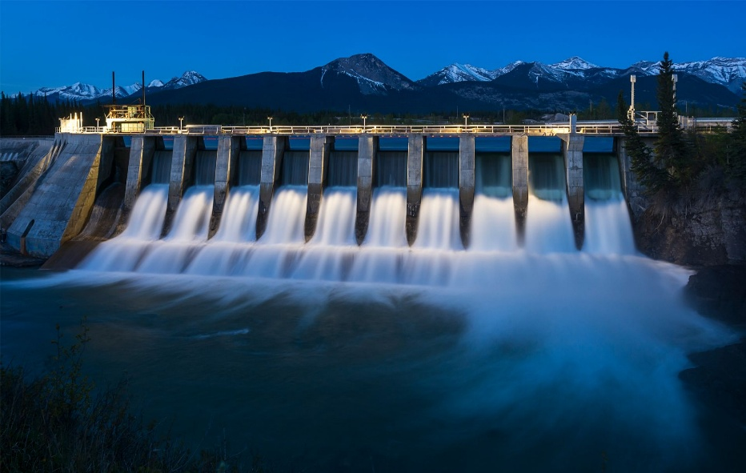
Figure 3: A hydroelectric dam producing electricity as flowing water spins turbines connected to generators.
Hydroelectric generation plants harness flowing water to spin turbines linked to generators. Many large dams use for flooding control and electricity generation (U.S. Energy Information Administration, 2023)

Evaluation: Hydropower offers one of the most efficient means for generating renewable energy, achieving efficiencies over 90 percent; however large dams can impact ecosystems and people living near the water.

Biomass Energy
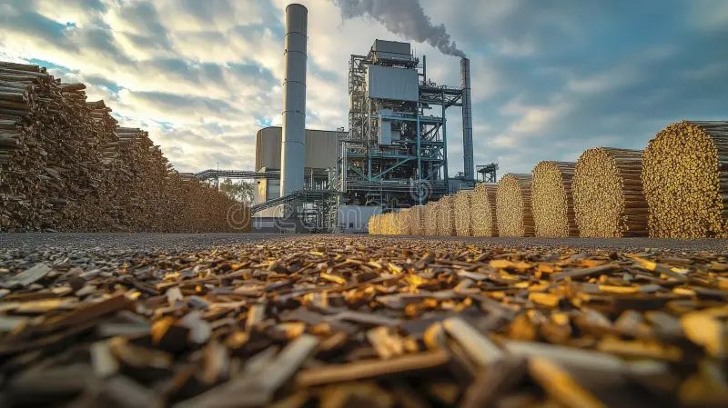
Figure 4: Biomass power plant generating electricity by using organic materials such as plant waste and agricultural residues as fuel.
Biomass energy is generated by burning or processing organic materials such as agricultural waste, wood and plant materials to produce heat and electricity (National Geographic, 2022).

Evaluation: Biomass helps reduce waste and can provide continuous energy supply but it may still produce emissions if not managed sustainably.

Nuclear Energy – Advantages and Disadvantages
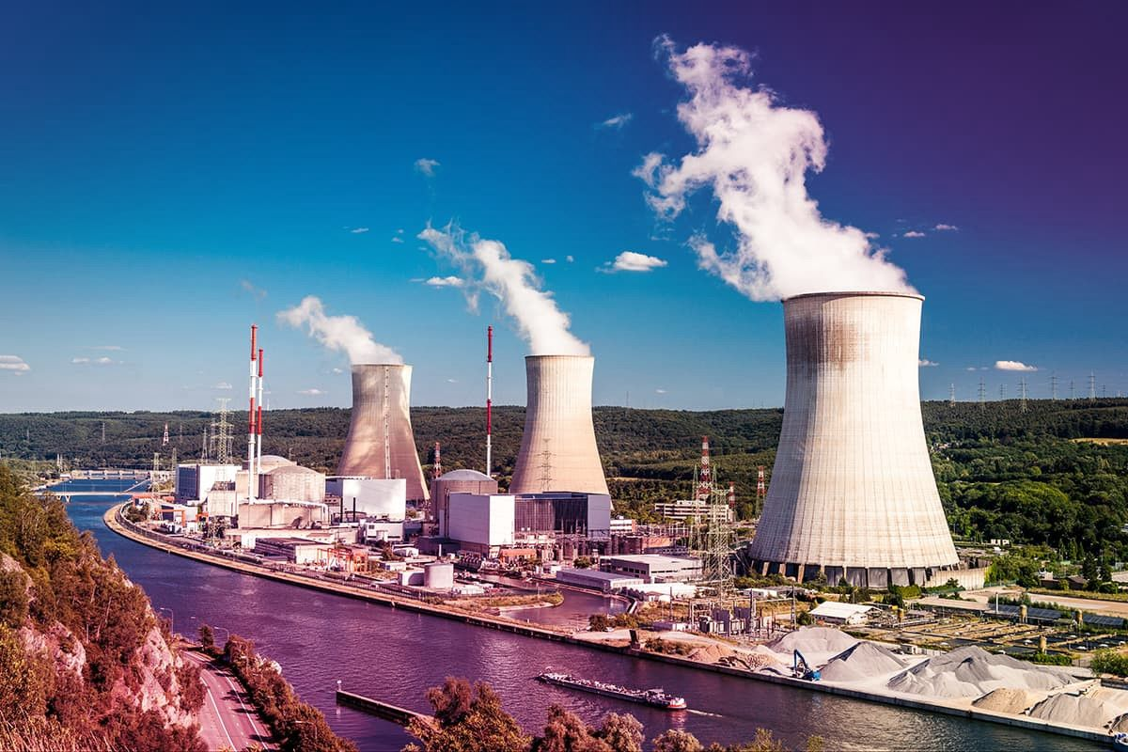
Figure 5: Nuclear power station generating electricity through nuclear fission reactions that produce heat to drive steam turbines.
Nuclear fission reactions produce heat in nuclear power plants, which turn the product of F2F into steam that is used to drive turbines and generate electricity. Nuclear power is capable of producing extremely large quantities of electricity with low emissions during operation (World Nuclear Association, 2023).
Advantages:
• High energy output
• Low greenhouse gas emissions
• Reliable electricity generation
Disadvantages:
• Production of radioactive waste
• Construction & safety expenses
• Danger of accidents and pollution
• Challenges for long term waste storage.

Comparison of Energy Sources
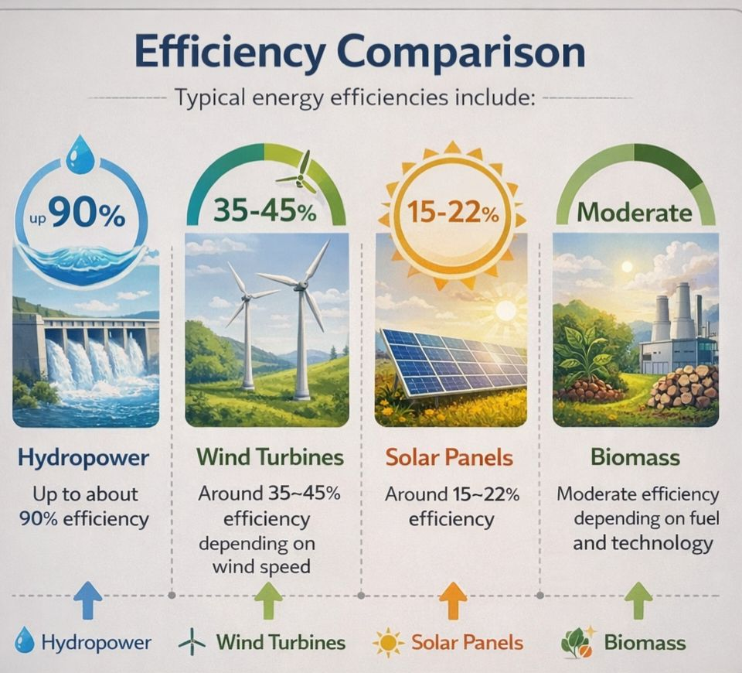
Figure 6: Modern renewable energy technologies including solar panels, wind turbines and energy storage systems improving electricity generation efficiency.
Most renewable energy sources are more sustainable than fossil fuels. Hydropower is very efficient, with efficiencies often exceeding 90%. Wind turbines are typically 35–45% efficient and solar panels range from 15–22% (depending on technology) (International Energy Agency, 2023).
Virgin fossil fuels like coal and gas can produce steady electricity, but emit huge quantities of carbon. Nuclear energy generates a great deal of power, but it also raises issues regarding safety and waste disposal (World Nuclear Association, 2023).

\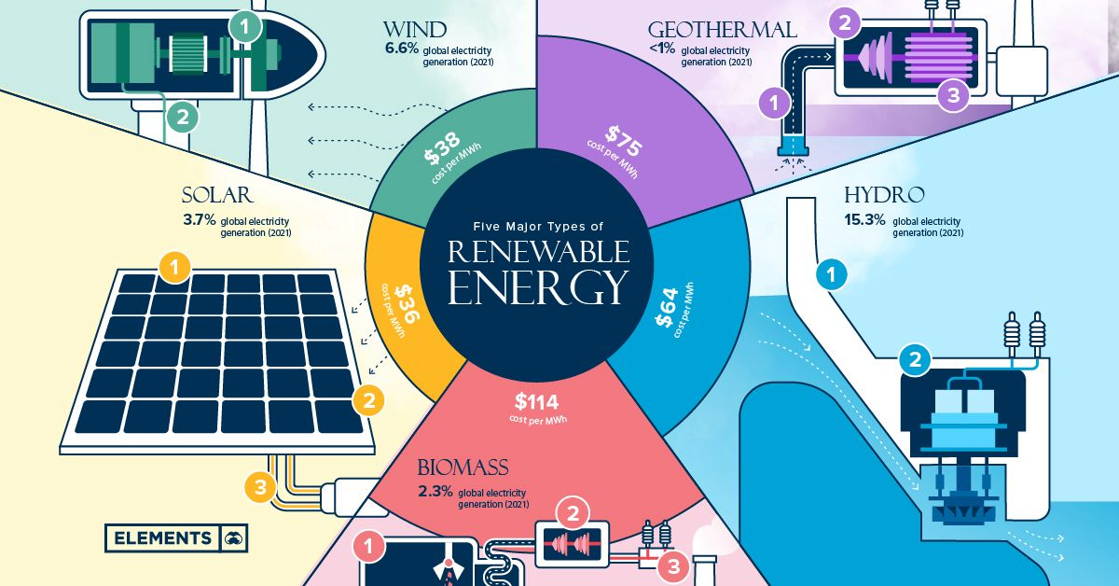
All in all, renewable energy is becoming economically more efficient with advancing technologies and resultant price reduction.

Conclusion

For a better future we need renewable energy sources. Despite the high initial costs of these types of equipment, against all odds, the technology in combination with low operating prices make such plants more efficient over time. Technologies such as solar, wind, hydro and biomass are environmentally friendly alternatives to fossil fuels. Nuclear energy is still a significant option but needs to be controlled due to safety and disposal problems.

References
Energy Saving Trust (2023) Renewable energy and solar power. Available at: https://energysavingtrust.org.uk
International Energy Agency (2023) World Energy Outlook and renewable energy analysis. Available at: https://www.iea.org
U.S. Energy Information Administration (2023) Energy explained: Hydropower and electricity generation. Available at: https://www.eia.gov
National Geographic (2022) Biomass energy. Available at: https://www.nationalgeographic.org
World Nuclear Association (2023) Nuclear power information. Available at: https://www.world-nuclear.org

